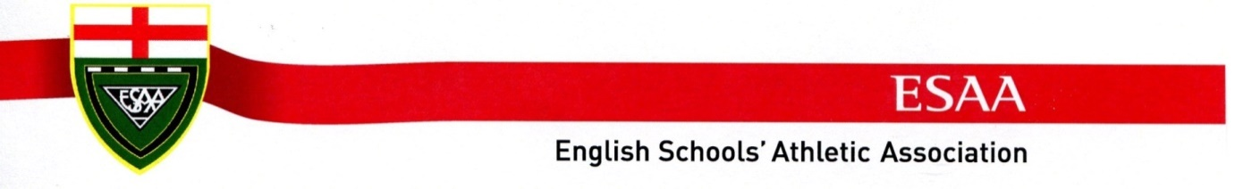
Track & Field Schools’ Cup – AWARD BADGES
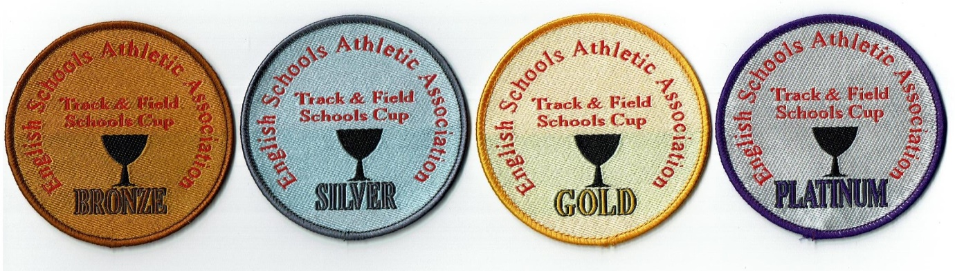
45 points | 35 points | 28 points | 17 points
Individual badges for achieving the above points score from both events including Relay
ORDER FORM | £1 per badge | No required
PLATINUM | 45pts
GOLD | 35pts
SILVER | 28pts
BRONZE | 17pts
 | Total:

Overall Cost (add on £2 for Email orders paid via BACs for P&P) | £

ORDER BY POST or EMAIL:- to Edna Beveridge
Barwick, 10 Reigate Square, Parkside Glade, Cramlington, Northumberland. NE23 1NW
e.beveridge@talktalk.net
Payment - Account Name …. English Schools’ Athletic Association - via cheque accompanied by appropriate sized STAMPED ADDRESSED ENVELOPE or via BACs Lloyds Bank, 30-92-79, 03219169

School Name |  | Teacher i/c
Email |  | Mobile No
School Address
School Address |  | POST CODE

